**NBA Player Analysis Report**

**Introduction**

This report provides an in-depth analysis of NBA player statistics, focusing on various metrics such as agility, weight, body fat, and other physical attributes. The data was analyzed and cleaned using Python in Jupyter Notebook, ensuring accuracy and reliability of the insights presented. The dashboard created using Power BI visualizes the data to help identify trends and insights that can be valuable for team managers, coaches, and sports analysts.

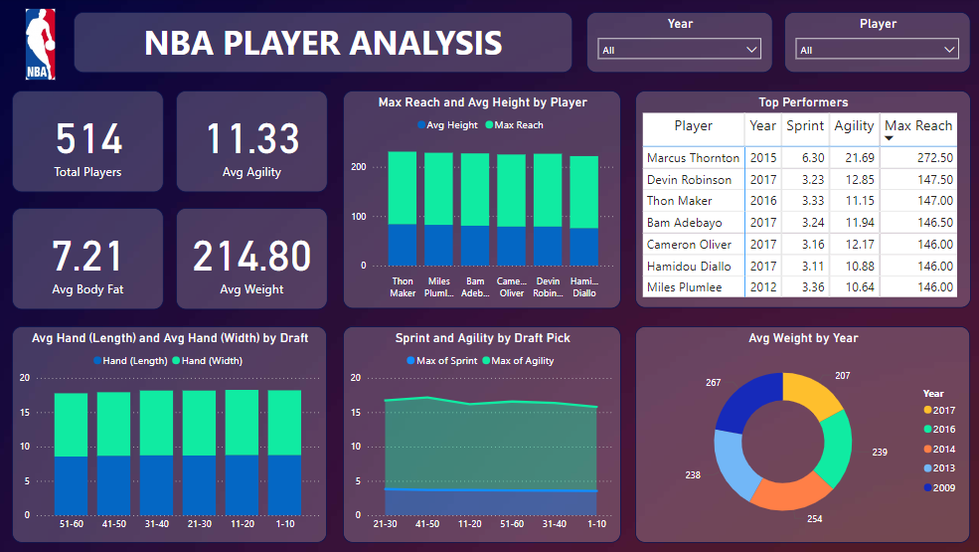

**Summary of Analysis**

1. **Overall Player Statistics**

* **Total Players Analyzed:** 514
* **Average Agility:** 11.33
* **Average Body Fat:** 7.21%
* **Average Weight:** 214.80 lbs.

1. **Average Draft Pick Position:**

The average draft pick position is 29 indicating that the dataset includes a mix of first and second-round picks, providing insights into a broad range of talent levels.

1. **Top Performers:**

The table lists the top performers in terms of sprint time, vertical jump (max reach), and agility. The top 3 players are:

* **Marcus Thornton (2015)**
* **Devin Robinson (2017)**
* **Thon Maker (2016)**

1. **Average Height (No Shoes) and Vertical (Max Reach) by Players**

The bar chart shows the average height and vertical reach of players. Taller players generally have higher vertical reaches, which is advantageous in the game for rebounding and shot-blocking.

**Key Findings**

1. **High Variation in Physical Attributes:**

The analysis revealed significant variations in physical attributes such as vertical reach, weight, and body fat among players. This indicates diverse physical conditioning and genetic factors at play.

1. **Top Performers Excel in Multiple Metrics:**

Players like Marcus Thornton and Devin Robinson showcased exceptional performance in multiple metrics, indicating their superior physical capabilities and training.

1. **Draft Pick Trends:**

The trends in sprint and agility metrics based on draft picks suggest that higher draft picks tend to have better physical performance, reflecting the scouting and selection process's effectiveness.

1. **Hand Measurements Consistency:**

Hand measurements remained relatively consistent across different draft pick ranges, suggesting that hand size may not be a significant differentiator among top players.

1. **Consistency in Height and Weight Measurements Over Years**

The average weight and height metrics have remained consistent over the years, indicating standardized training and conditioning programs.

**Recommendations**

1. **Focused Training Programs:**

Implement specialized training programs targeting agility and sprint performance to enhance overall player fitness. Focus on drills that improve reaction times and explosive movements.

1. **Scouting and Drafting:**

Use the identified trends in draft pick performance to refine scouting and drafting strategies. Prioritize players with superior agility and sprint metrics for early draft picks.

1. **Injury Prevention:**

Given the high variation in physical attributes, develop personalized conditioning and rehabilitation programs to prevent injuries, especially for players with extreme measurements.

**Conclusion**

The NBA Player Analysis provides valuable insights into the physical attributes and performance metrics of draft candidates. By leveraging these insights, teams can make informed decisions on training, scouting, and player development, ultimately enhancing their competitive edge.